**PHGY 209**

**BODY FLUIDS**

**Fundamental Principle**

* In all levels of organization, functional activities’ goals are to maintain Homeostasis, the relative constancy of “Milieu Interieur”

**Claude Bernard 🡪 “Milieu Interieur”**

1. Environment surrounding individual cells is vastly different from external environment
2. Internet environment remains relatively constant under conditions of health

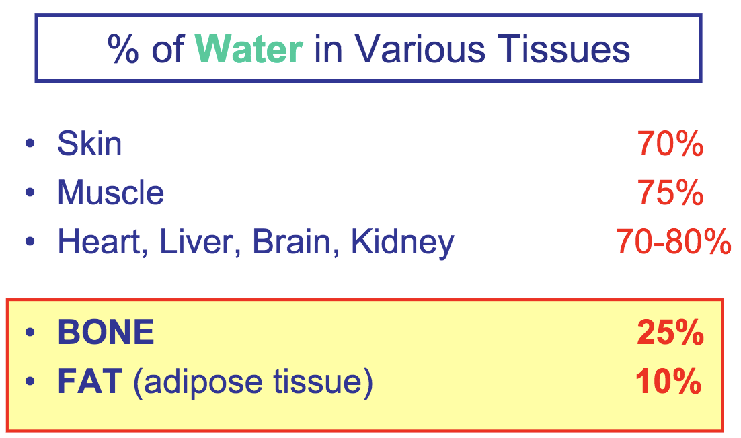

**Body water**

* A medium which
  + Solute dissolves
  + Metabolic reactions take place
* Remains constant 🡪 dynamic steady state
  + Helps to maintain normal solute concentration & normal blood pressure & volume
    - 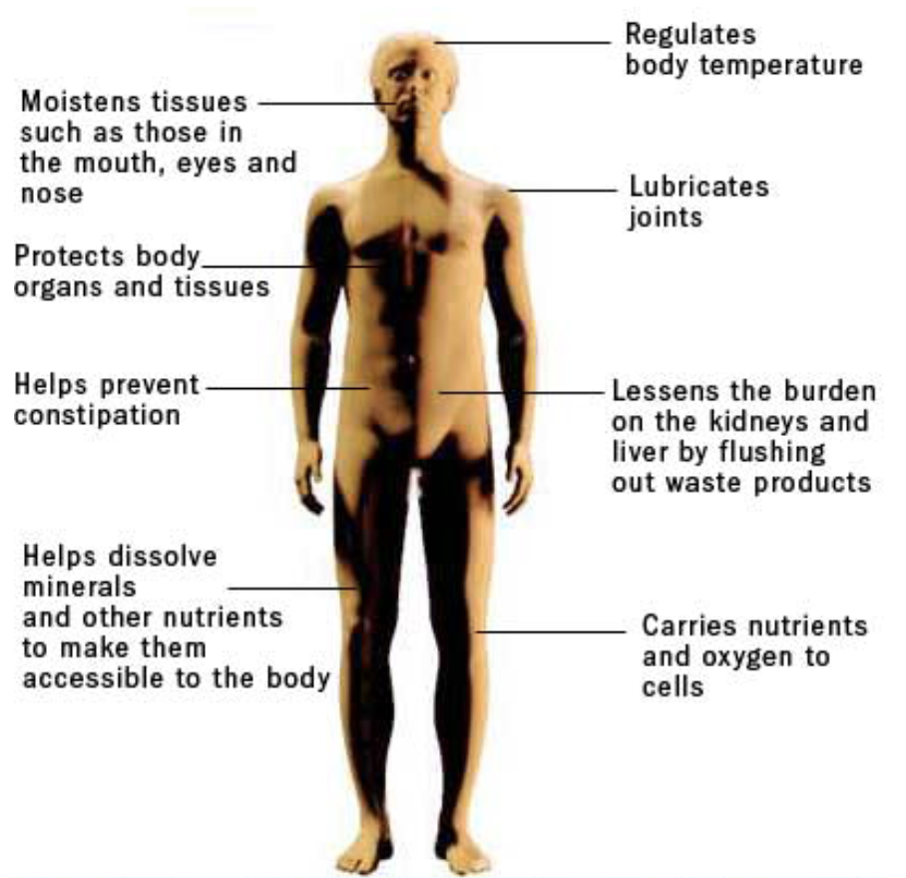Adequately supply O2 to tissues

**Aspects of Body fluids**

* Volume
  + Body consists of 45-75% water
* Distribution
* Characteristics
* Functions
  + Water is important for (see diagram)
  + Variant in water content depends on FAT (adipose tissue)
    - If the body water content is computed as a fraction of lean body mass (excluding fat), the difference between individuals become insignificant.
  + Variant in water content depends on age & gender, weight & Ethnic origin
    - All Infant has highest water %; loses it quicker, higher sensible rate
    - Females have less than males (from estrogens)
    - Aging causes the dryness of tissues because of muscle loss; replaced by connective tissue (drier) 🡪 changes in bone density and increases in deposition of fats
    - Significant for administering water-soluble medications

**Water Balance**

* Intake
  + Oral fluid, Oral intake as food (goes to gastrointestinal tract)
  + Oxidative water from metabolism
* Output
  + Lungs, skin 🡪 insensible (happens unconsciously)
  + Kidneys and stool (feces)

**Obligatory losses**

* Loses water regardless of the intake
* Ex. Insensible, urine + stool

**Facultative losses**

* Vary with intake
* Ex. Urine (Kidney is major hemostatic organ)

|  |  |
| --- | --- |
| **Insensible Perspiration** | **Sweating** |
| 1. Pure water 2. Passive evaporation  * Affected by ambient temp. & humidity  1. Entire skin surface    * Present even in individuals lacking sweat glands 2. Continuous | 1. Electrolyte solution 2. Active secretion 3. Sweat glands 4. Activated by heavy work/high temp. |

**A Negative Water Balance (5)**

* + Reduced intake
  + Excessive loss from gut
  + Excessive sweating
  + Excessive loss in expired air (at high altitudes)
  + Excessive loss in urine

**Water “Intoxication” (2)**

* + Excessive intake
    - Decrease electrolyte & Na+ concentration (marathon runners, over hydrated) 🡪 Death
  + Rental system failure
    - Excess retention of water

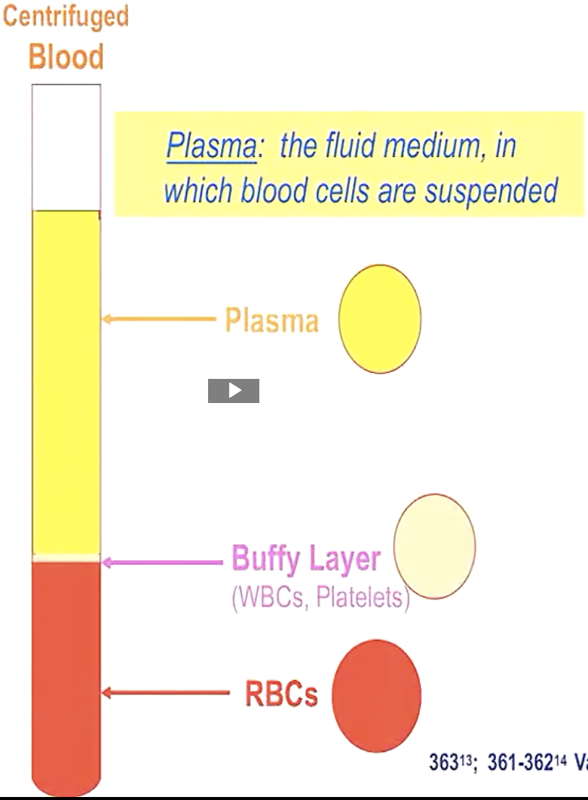

**Body Water Compartments**

* + Total body water = 60% of body mass

**2 Major compartments (NOT ISOLATED, EXCHANGEABLE)**

* + One of these is further subdivided into:
    - 2 major sub-compartments
    - 2 minor sub-compartments
    - Differs in
      * Size
      * Composition (ionic)
      * Function

**Intracellular Fluid (ICF)**

* + 2/3, 40% of Body Mass
  + Aggregate of fluid bound by internal surface of cell membranes

**Extracellular fluids (ECF)**

* + 1/3, 20% of Body Mass
  + 2 major and 2 minor sub-compartments
    - Major: Plasma (5%), interstitial Fluid (ISF) (15%)
    - Minor: Lymph, Transcellular Fluid

**Hematocrit (Ht)**

* + Percentage of Blood volume that is occupied by Red Blood Cells (erythrocytes)
  + Ht = Packed Cell Volume (PCV)
    - Normal Value = ~45%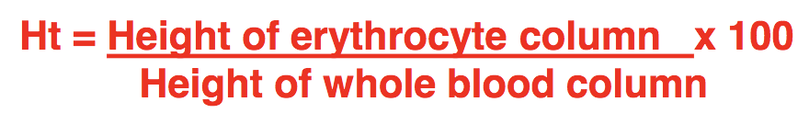
    - Plasma comprises 55% of blood volume

**Interstitial Fluid (15%) –** True “Milieu Interieur”

* + Fluids that percolates between individual cells (Freely moving)
    - Important for exchange of gases and nutrients in & out of capillary

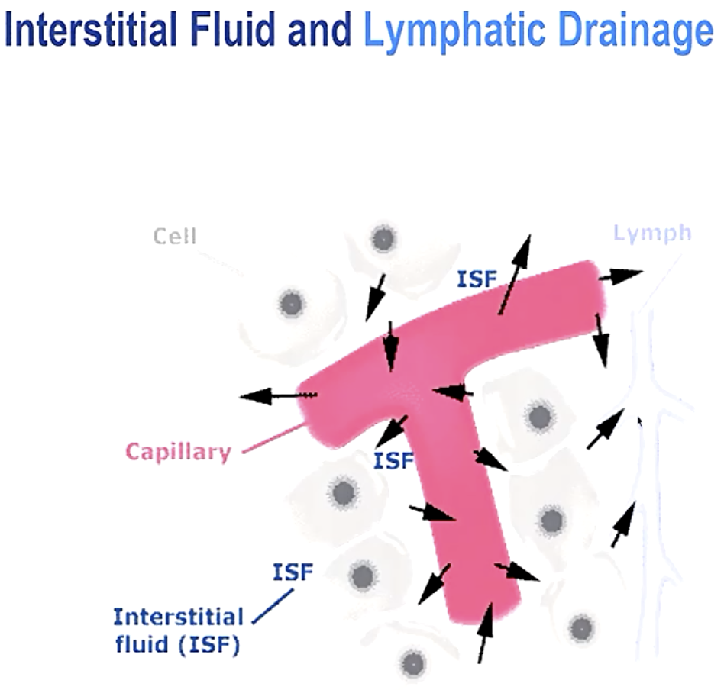

**Lymphatic Drainage**

* + Collects fluid that is not collected by capillary to lymph vessels back into circulatory system
  + Lymph – specialized fluid that remains the extracellular fluids that is taken back up into the blind tubules
  + 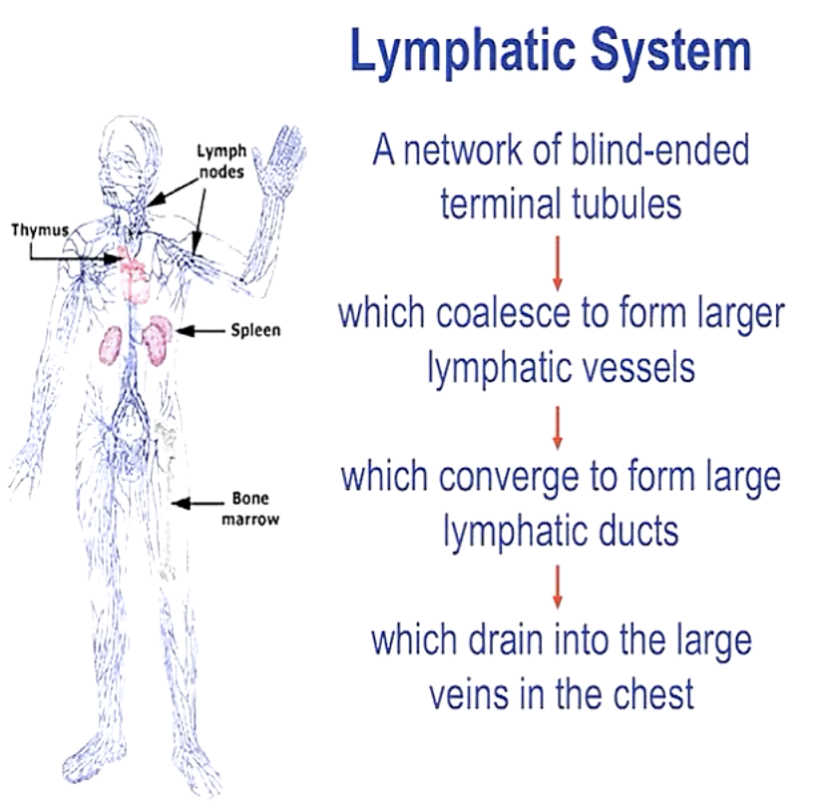One-way system
  + Lymph Volume < 1-2% of ECF

**Transcellular Fluid**

* + 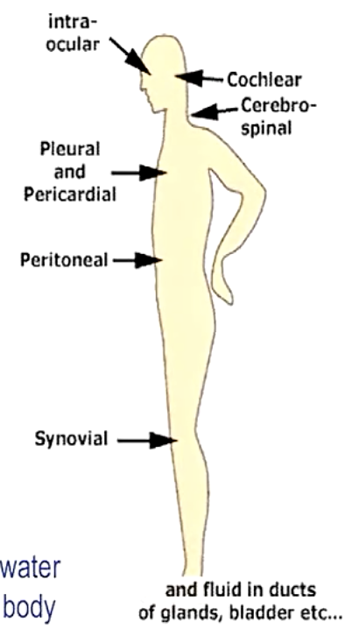Aggregate of small fluids volumes secreted by specific cells into a # of body cavities (lined by epithelia cells) and having specialized functions
  + Volume < 1-2% of ECF
  + Does NOT contribute to overall water exchanges; local exchanges do not affect body fluid balance

**Body Fluids Summary**

* + Total volume remains constant
  + 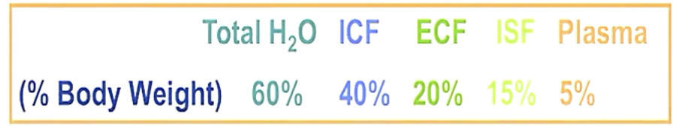Relative distribution between compartment remains constant
  + Compartments are in a state of Dynamic equilibrium

**Methods to determine compartment volumes**

* + Direct
    - Weight 🡪 Drain (dry) 🡪 Weight
  + Indirect
    - Indicator dilution method
      * All you need to know is:
      * **Total quantity** of test substance introduced
      * **Concentration** of the substance/unit volume of fluid, after dispersion
        + V = Q/c

1. Introduce known Quantity (Q) of indicator into vein
2. Allow time to equilibrate
3. Remove known volume of blood and centrifuge to obtain plasma
4. Measure concentration in unit volume of plasma
5. Calculate

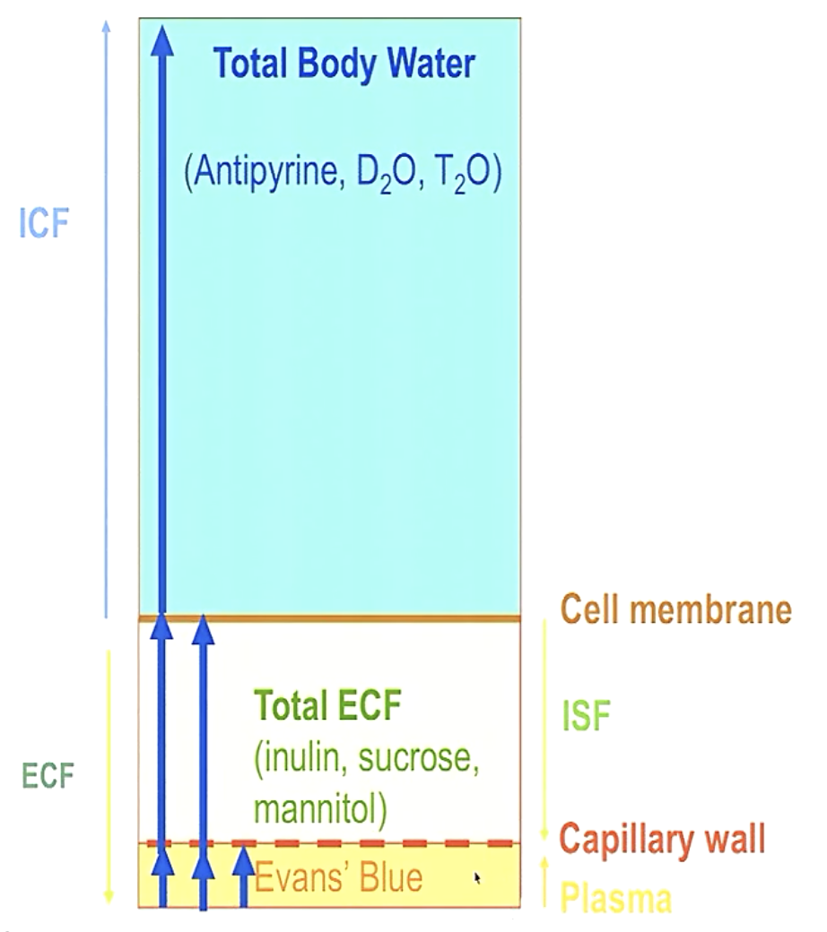**Indicator Choice (see figure)**

* + Non-toxic
  + Diffuse readily, distribute evenly throughout compartment
  + Induce NO changes in distribution of H2O btwn compartments
  + Easy to measure
    - Note: In a clinic situation, must correct for any amount which has been removed from body by metabolism or excretion during the time allowed for mixing.
  + 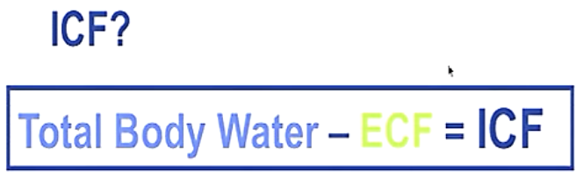Body fluids are essentially aqueous solutions of inorganic ions w/ carriable amount of proteins

**Body fluids – ionic composition**

ICF

* + High in K+, Mg+2, low in Na+ and Cl-

ECF

* + High in Na+, Cl-, low in K+
  + Difference btwn ISF & Plasma – Plasma is higher in protein

**Artificial Physiological Solutions**

* + Substitute for plasma/ISF
  + 0.9% saline